Introduction to Landform Regions
- Use page 105 in the Physical Geography textbook to help you label and colour the map the major landform regions of Canada.
- Look at Figure 6.15 on page 105. It shows us what Canada looks like. What are 2 interesting observations you can make from looking at this profile?

- Look at Figure 6.16 on page 106. Mountain ranges seem to be concentrated in two or three specific places in the world. Why do you think that is?

- Look at Figure 6.20 on page 109. You can see that plains do not cover a lot of our world. What effects do you think this has on people?

- Look at the map on page 113. Create a Venn Diagram to compare the physical ways North America and South America are the same and different. Then make an inference to explain why you think these similarities and differences exist.
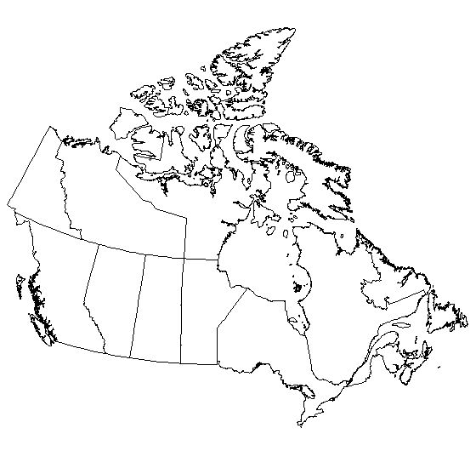
Legend
Appalachian Mountains
Western Cordillera
Innuitian Mountains
Interior Plain
Great Lakes – St. Lawrence Lowlands
Hudson Bay Lowlands
Arctic Lowlands
Canadian Shield

Title: _____________________________

